Types of Tickets :-

1. Change Management :-
2. Change Queue = **CR**
3. Change Task Queue = **CT**
4. Incident Management :-
5. Incident Queue =**IR**
6. Request Fulfillment :-
7. Request Queue = **RR**
8. Request Task Queue =**RT**

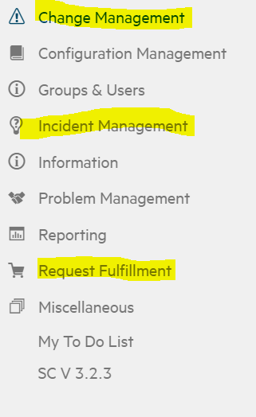

1. Change Management :-
2. Change Queue = **CR**
3. Change Task Queue = **CT**

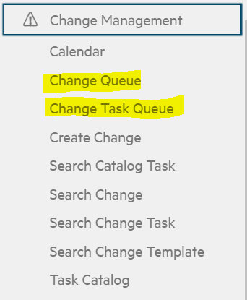

1. Incident Management :-
2. Incident Queue =**IR**

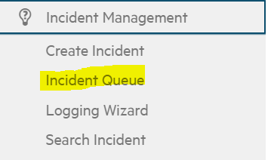

1. Request Fulfillment :-
2. Request Queue = **RR**
3. Request Task Queue =**RT**

